**Game Summary**

**Game General Description**

It is undeniable that shooting game has been one of the most attractive types of game for a long time. A shooting game can be even much more exciting with a good story line. Hydrobot Adventure is a very special shooting game with 12 levels, a lot of unique game play features and an intriguing storyline.

**Game Intention**

Hydrobot Adventure makes the player learn about under-sea environment sustainability and what can be done to save it as part of the game play, without preaching it. The game also brings to the mind of the player a vision of what the sea environment will become in the future if we do not act right now.

**Game Play Features**

Hydrobot Adventure is a game in which you play as a hydrobot on his quest to save the oceans. The game captures the real under-sea environment with water effects and cool graphics.

The hydrobot has to clean ocean debris, heal animals and drop seeds on the ocean bed to grow a special plant.

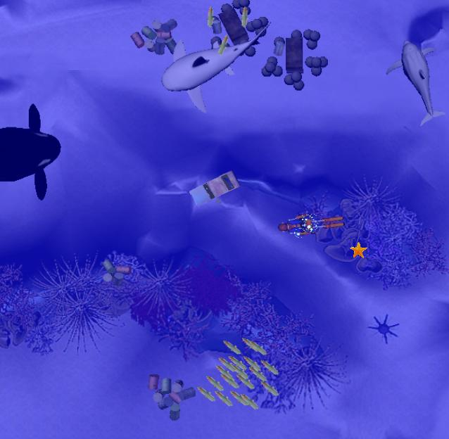

*Figure 1. Game environment with sea animals, schools of fish, corals and trashes on the seabed*

The environment status shows how polluted the sea is and how many sea animals have been killed. The worse the environment status, the quicker the sea animals’ health reduces over time.

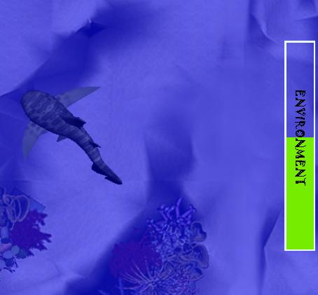

*Figure 2. In game environment bar showing environment status*

Each game’s level has a different objective. The sole purpose of the game is not to just clean the ocean or heal the animals. Doing these things is means of spreading awareness. Simultaneously it gives the player experience points that can be used towards leveling up and obtaining greater skills. The hydrobot can use these experience points for various attributes.

Strength – Increasing his shooting power,

Speed – Increasing his mobility.

Shooting rate – Making him shoot faster

Health points – Increasing his chances of survival.

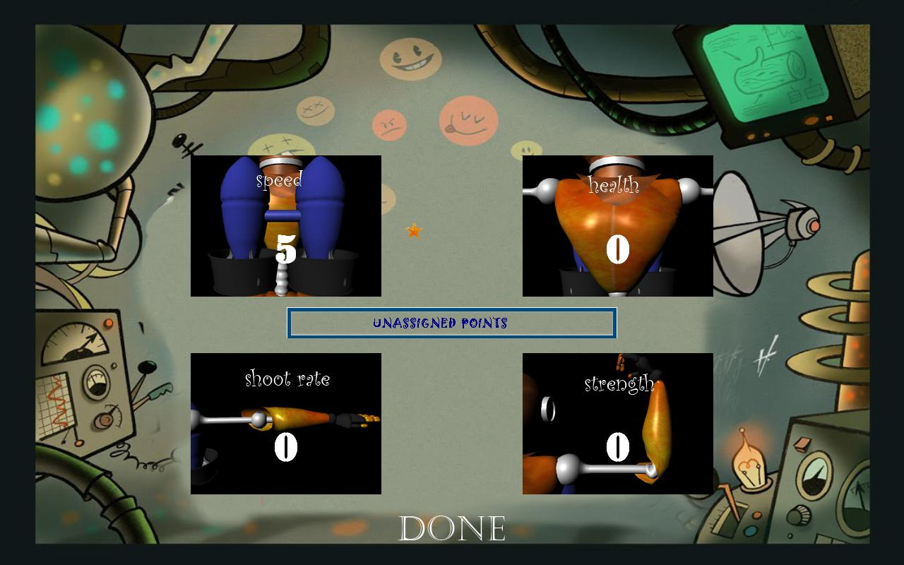

*Figure 3. In game attribute board for improving the hydrobot*

The hydrobot is able to function infinitely under water. The special fruits planted from the hydrobot himself, supplies him with an infinite power source. The fruits will not only replenish our hydrobot with health and temporary power-ups but will also serve as a means of restoring the overall environment condition.

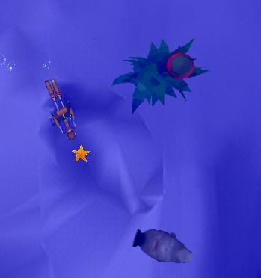

*Figure 4. A grown up tree gives out fruit periodically*

To make the game more interesting, there are stage bosses in the game where the hydrobot’s current power cannot overcome. In order to defeat them, the player will need to follow the instruction of Poseidon to find the ancient mythological relics. These relics are left forgotten in treasure chests inside shipwrecks. These treasure chests are heavily locked and opening them without the key is impossible. However, the fishes populating the area know the way to the sacred key. Therefore, helping the animals will lead the player to the key allowing you to overtake the bosses.

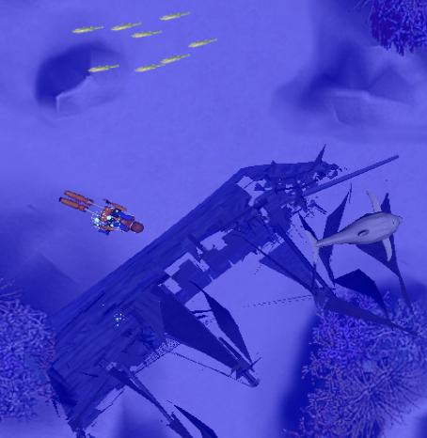

*Figure 5. A shipwreck lying on the seabed*

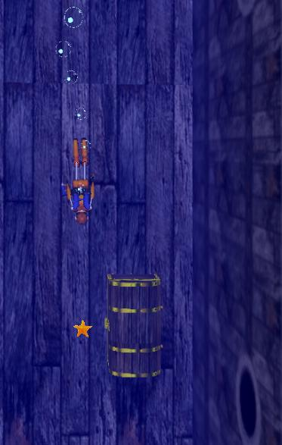

*Figure 6. Exploring treasure chests inside shipwreck*

With the relics, the player is able to learn special skills that will make the fight with the big bosses possible. The power of each skill is related to the hydrobot’s basic attributes. Accordingly, the player will have to strategize when choosing which skill to master. For example, the power of Thor’s hammer is linked to our bot’s strength. However, each skill is a double-edge sword. Using the power to much can adversely damage the Hydrobot.

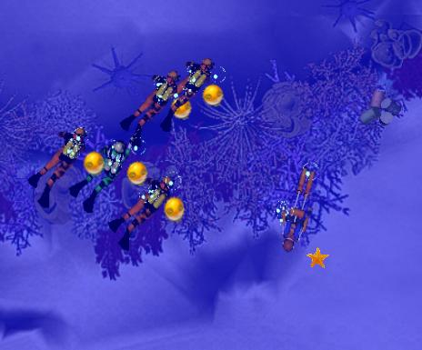

*Figure 7. Use Thor’s hammer to damage and stun a group of enemy inside an area*

By playing this game, the player will learn easy ways to help change the world! The treasure chests not only contain relics but also contain paintings of the sea. These paintings describe a sea environment that is much better than the current game’s environment. The paintings will also give players facts and hints that not everybody knows about. The ocean animals will also show their unique abilities, and offer interesting ways on saving the oceans.

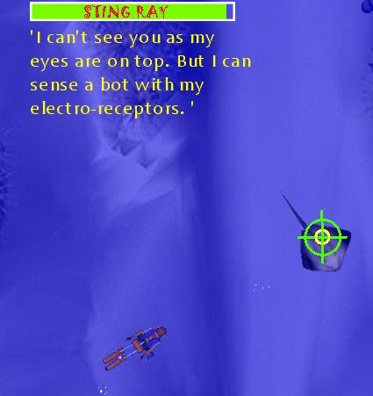

*Figure 8. The Hydrobot can understand sea animal languages*

These information are needed in the minigame after every level. There are 2 minigames: quiz game and typing game. In the quiz minigame, the player would have to answer several questions regarding the sea environment. Answering more questions correctly means we have successfully educated more hunters, turning them from bad to good. The next level will be easier for you. These hunters will stop polluting the environment and hunting the animals. The starting environment status of the next level will be higher.

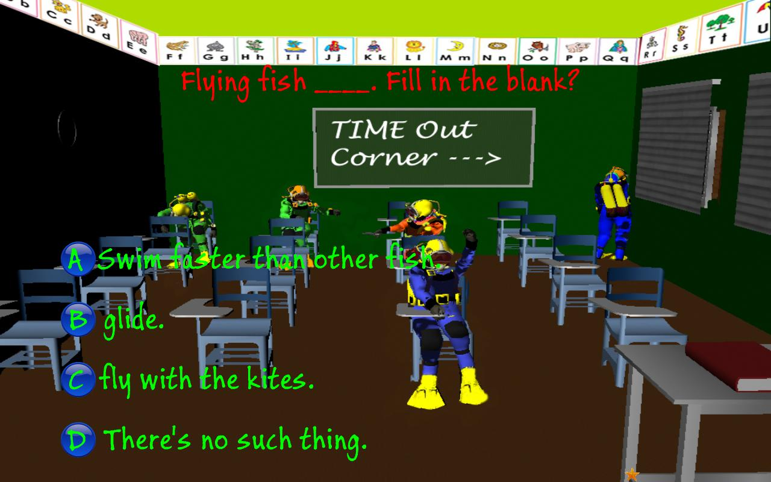

*Figure 9. Educate hunters by playing Quizz minigame*

In the typing mini game, you will have to type an educational passage correctly in a limited time period. The faster you type, the more experience the hydrobot will gain!

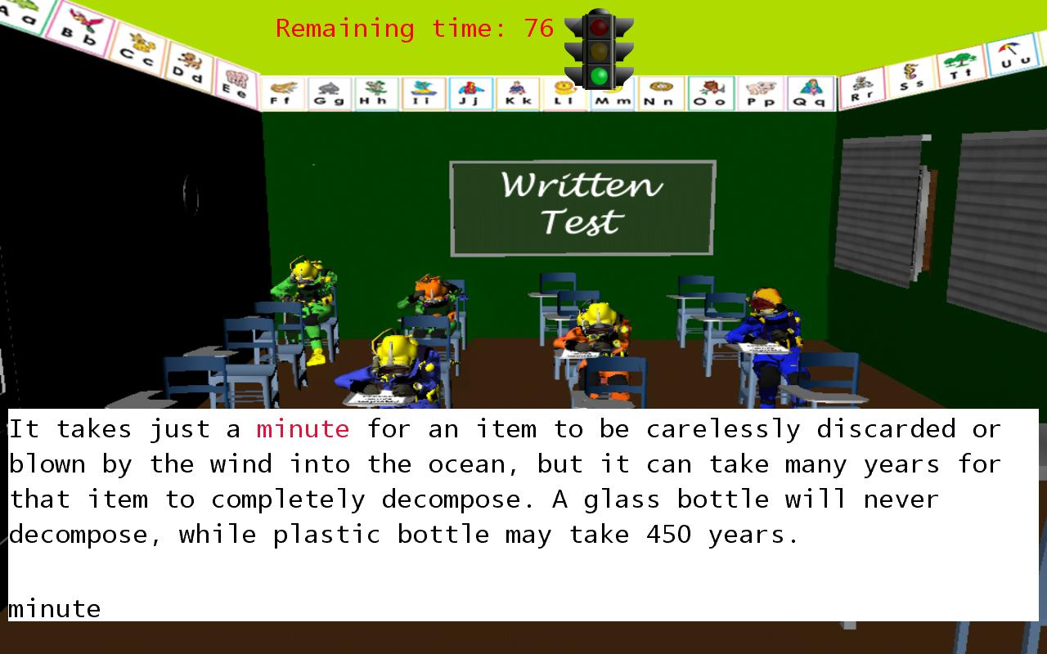

*Figure 10. Educate hunters by playing Typing minigame*

**Future Work**

Hydrobot Adventure is now a completely playable game but we aim to even bring many more new features to improve both of its fun and education factors in the near future. Some of the possible improvements include:

* “New game +” or different difficulty levels to enhance the replayability factor of the game and satisfy both casual and hardcore gamers.
* Making the in-game shooting much more dynamic and fun with random factors.
* Opening the treasure chests will also gives the player fragments of extinct sea animals’ fossils. Collecting enough fossil fragments will let the player to play a jigsaw type of minigame, successful in which will bring the extinct sea animal back to life and information about itself along with the reason of its extinction. The revived sea animal will be able to assist the player in battle with its unique ability.

Any idea for improving this game is welcome. If you would like to contribute an idea, please feel free to send email to any of our team members.

**Team Members**

Team leader: Hien Nguyen [hien.nguyen.nx@gmail.com](mailto:hien.nguyen.nx@gmail.com)

Developer: Khoa Le [khoatatle@gmail.com](mailto:khoatatle@gmail.com)  
Developer: Debjyoti Majumder [debjyoti.majumder@gmail.com](mailto:debjyoti.majumder@gmail.com)

Animator: sushil joshi [sushil118@gmail.com](mailto:sushil118@gmail.com)

 **Acknowledgements**

This game and its trailer have been done with the help of:

Jose Baez-Franceschi: Team mentor

Meghna Saha: Kid voice in the trailer

Bryan Panjavan: Man voice in the trailer

**Important Note:**

* **None of the sound tracks appear in this game and its trailer is the property of Eager Beavers. They were written and played by different artists and the sound tracks were available for free download.**
* **This game is currently for educational purpose only and is not a commercial product.**